sion consists of.

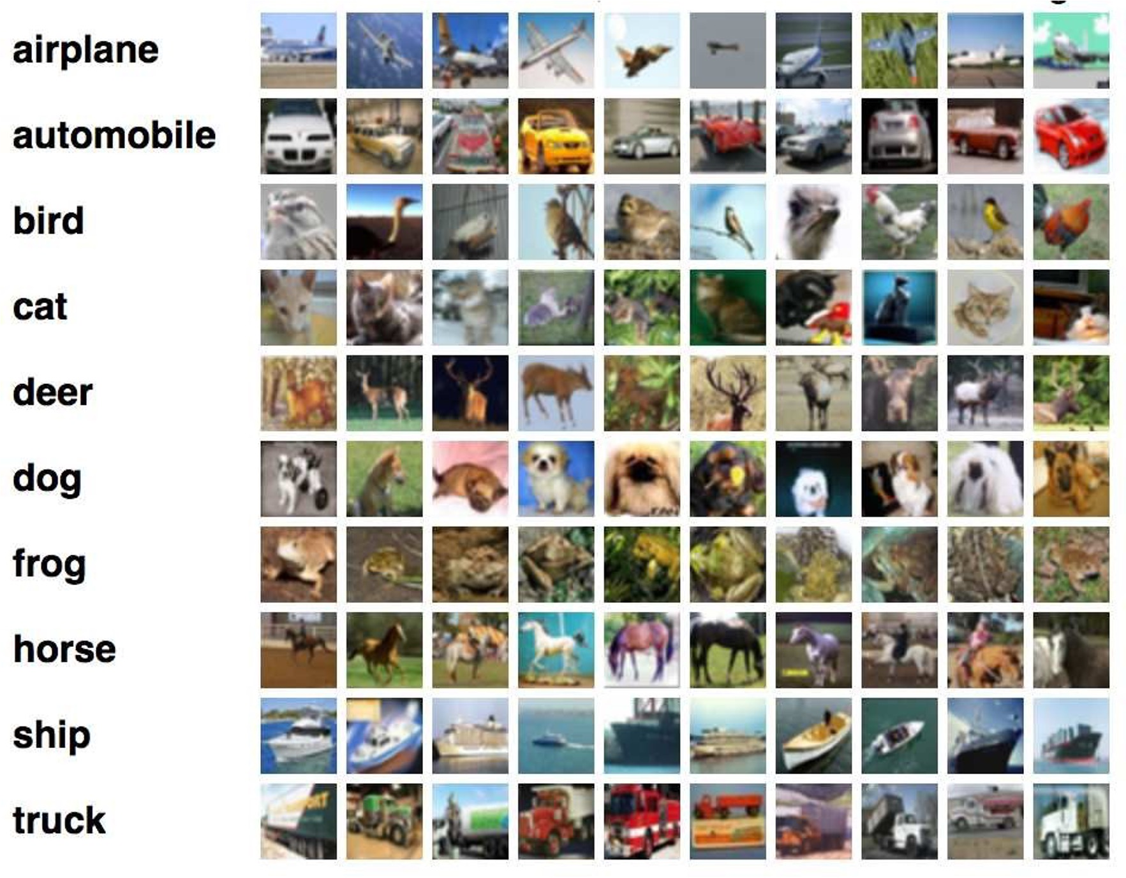

# Image classification with the CIFAR10 data set (included in Keras)

* Data set of 50,000 images for training and 10,000 for testing
* RGB (full colour) images of 32x32 pixels
* Images tagged in 10 different classes

# Objective of the project:

* + Testing 5 (or more!) different combinations of elements (Network architecture, data augmentation…)
  + Collecting the results and analysing

them

* + Giving a global comparison among the (at least) 5 combinations